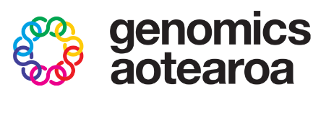
Summer Institute of Statistical Genomics Student Scholarship

With the generous support of Genomics Aotearoa, we are delighted to offer postgraduate student scholarships to support registration costs to attend up to four modules of the Summer Institute of Statistical Genomics.
You must be a current postgraduate student (PGCert, PGDip, Hons, MSc or PhD/DPhil) at an institution in New Zealand.
(Important note: applicants should not register to the Institute before their application outcome is known).
Students will need to make their own arrangements for travel and accommodation.
Name of applicant
Applicant email address
University / Institute and degree enrolled in (PGDip, Hons, MSc, PhD)
Name of supervisor(s)
Intended modules at SISG (see list on next page; full details are available in the Institute information booklet)

Award checklist
The following documents should be included and merged into a single pdf document:
- this completed cover sheet (first page only of this document)
- the applicant’s CV (no more than two pages)
- a one page letter that outlines of the applicant’s interests in the field of statistical genomics and provides a statement about how each of the modules will further their training and development (no more than one page)

How to apply
The merged pdf document should be submitted by email by midnight (NZST) Tuesday 1st September 2026 to both SISG Coordinators Prof Bruce Weir (bsweir@uw.edu) and Assoc Prof Anna Santure (a.santure@auckland.ac.nz) with “SISG student scholarship” in the subject line.
Summer Institute in Statistical Genomics Modules
Modules last 2.5 days, starting on Monday morning and ending Wednesday lunchtime, or from Wednesday afternoon through Friday afternoon. Each module runs as 10x 90 minute sessions, generally alternating lectures and practical exercises.
Please see the information booklet for the Institute for full course descriptions, required background, and instructor biographies.

Week One: Monday 23 November – Friday 27 November
Mon 23/11/26 - Wed 25/11/26 | Wed 25/11/26 - Fri 27/11/26
1. Statistical Genetics  Bruce Weir | 2. Conservation and Population Genomics  Anna Santure & Emma Carroll
1. Statistical Genetics  Bruce Weir | 3. Introduction to Bayesian Statistics  Brendon Brewer

Week Two: Monday 30 November – Friday 4 December
Mon 30/11/26 - Wed 2/12/26 | Wed 2/12/26 - Fri 4/12/26
4. Comparing Patterns of Quantitative Genetic Variation  David Aguirre | 6. Applied Quantitative Genetics  Ken Dodds & Timothy Bilton
5. Polygenic Risk Scores  Yalu Wen | 7. Metagenomics and Gene Function Analysis  Kim Handley & Chloe Van Der Burg

With our thanks to all our generous event partners:
