EDCR332 – Space:
- Fill in Diagram
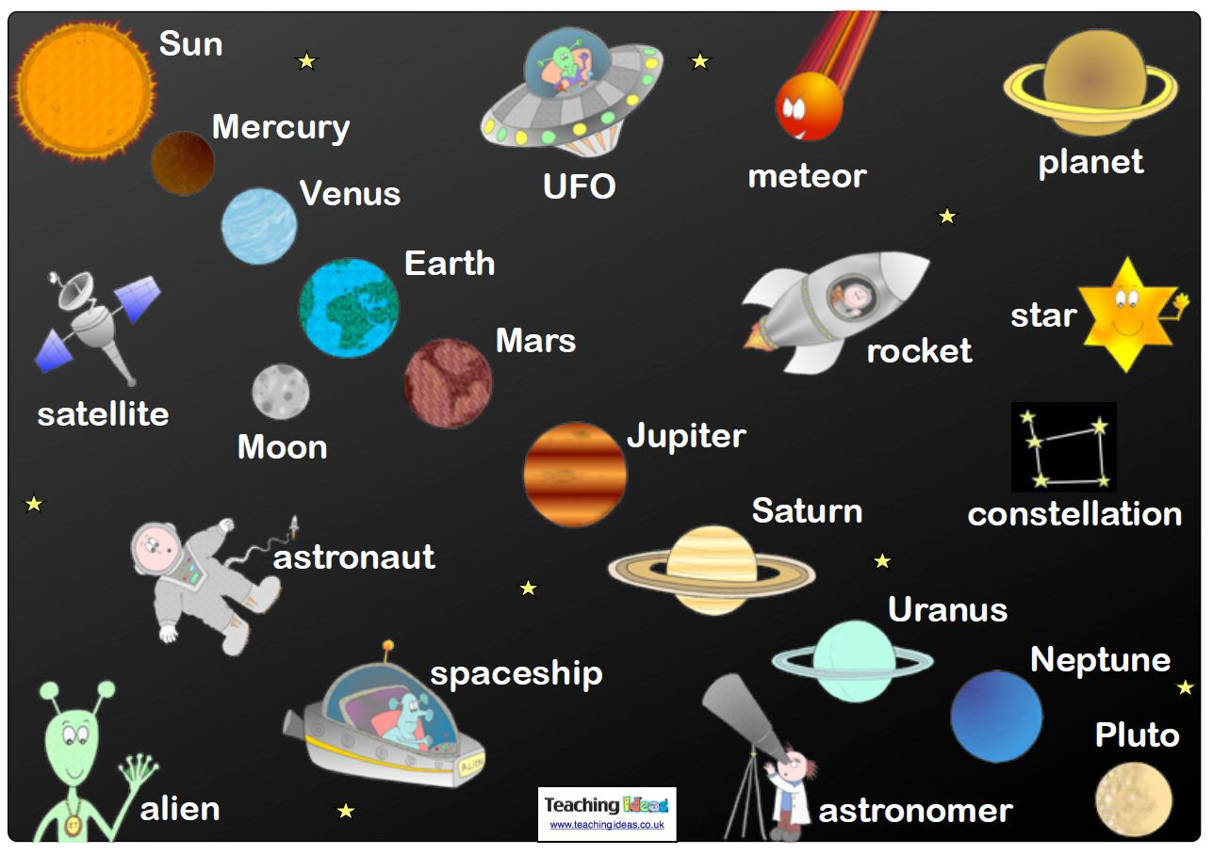
- Decision-making diagram:
“What if you were asked by aliens to go with them?”
(http://www.worksheetworks.com/miscellanea/graphic-organizers.html) – resource for making graphic organisers

What would you need?
MRS GREN – movement, reproduction, sensitivity, growth, respiration (this is getting energy out of food, for animals this needs oxygen but plants use carbon dioxide), excretion, and nutrition (for us food and water)
What about – Heat and Shelter

Content:
What is in Space? – not much, in fact it is mostly a vacuum of almost nothing, almost no temperature, unless close to a large object no gravity.
http://www.solarsystemscope.com/

What is the temperature in space?
There are three ways that heat can transfer: conduction, convection, and radiation.
Heat up one side of a metal bar, and the other side will get hot too; that is conduction. Circulating air can transfer heat from one side of the room to another; that is convection. But, out in the vacuum of space, the only way heat can transfer is radiation.
Photons of energy get absorbed by an object, warming it up. At the same time, photons are radiating away.
If the object is absorbing more photons than it emits, it heats up. And, if it emits more photons than it absorbs, it cools down.
There is a theoretical point at which you cannot extract any more energy from an object, this minimum possible temperature is absolute zero. Let us look close to home, in orbit around the planet, at the International Space Station.
A piece of bare metal in space, under constant sunlight can get as hot as two-hundred-sixty (260) degrees Celsius. This is dangerous to astronauts who have to work outside the station.
If they need to handle bare metal, they wrap it in special coatings or blankets to protect themselves.
And yet, in the shade, an object will cool down to below -100 degrees Celsius.
Astronauts can experience vast differences in temperature between the side facing the Sun, and the side in shadow. Their spacesuits compensate for this using heaters and cooling systems.
Let us talk a little further out. As you travel away from the Sun, the temperature of an object in space plummets. The surface temperature of Pluto can get as low as -240 Celsius, just 33 degrees above absolute zero.
Clouds of gas and dust between the stars within our galaxy are only 10 to 20 degrees above absolute zero.
And if you travel out far away from everything in the Universe, you can never get lower than a minimum of just 2.7 Kelvin or -270.45 Celsius. This is the temperature of the cosmic microwave background radiation, which permeates the entire Universe.
In space? It is as cold as it can get.

Space links well with Measurement (temperature, distance, size, etc.), Geometry would need a huge area to make the orbits reality. This shows how to scale (size and distance) the Solar System to 1,000 metres
http://www.noao.edu/education/peppercorn/pcmain.html

How many planets are in our Solar System?
http://www.kidsastronomy.com/solar_system.htm - very student friendly
http://chicago.suntimes.com/news/new-definition-would-make-pluto-a-planet-again/ - March 21st, 2017

Why is Pluto not a planet?
On August 24, 2006, the International Astronomical Union (IAU), an organization of professional astronomers, passed two resolutions that collectively revoked Pluto's planetary status. The first of these resolutions is Resolution 5A, which defines the word "planet." Although many people take the definition of "planet" for granted, the field of astronomy had never clearly defined what is and is not a planet.
https://www.nasa.gov/audience/forstudents/k-4/stories/nasa-knows/what-is-pluto-k4.html
Here's how Resolution 5A defines a planet:
A planet is a celestial body that (a) is in orbit around the Sun, (b) has sufficient mass for its self-gravity to overcome rigid body forces so that it assumes a hydrostatic equilibrium (nearly round) shape, and (c) has cleared the neighbourhood [sic] around its orbit.
Pluto is relatively round and orbits the Sun, but it does not meet the criteria because its orbit crosses Neptune's orbit. Critics of the resolution argue that other planets in the solar system, including the Earth, have not cleared the neighbourhood around their orbits. The Earth, for example, regularly encounters asteroids in and near its orbit.
Resolution 5A also establishes two new categories of objects in orbit around the sun: dwarf planets and small solar-system bodies. According to the resolution, a dwarf planet is:
A celestial body that (a) is in orbit around the Sun, (b) has sufficient mass for its self-gravity to overcome rigid body forces so that it assumes a hydrostatic equilibrium (nearly round) shape, (c) has not cleared the neighbourhood [sic] around its orbit, and (d) is not a satellite.
Small solar-system bodies are objects that orbit the Sun but are neither planets nor dwarf planets. Another resolution, Resolution 6A, also specifically addresses Pluto, naming it as a dwarf planet.
Not all astronomers support Resolutions 5A and 6A. Critics have pointed out that using the term "dwarf planet" to describe objects that are by definition not planets is confusing and even misleading. Some astronomers have also questioned the resolutions' validity, since relatively few professional astronomers had the ability or opportunity to vote.
Here is how the two resolutions classify the objects in orbit around our sun:
- Planets: Mercury, Venus, Earth, Mars, Jupiter, Saturn, Uranus, Neptune
- Dwarf planets: Pluto, Ceres (an object in the asteroid belt between Mars and Jupiter), 2003 UB313 (an object farther from the Sun than Pluto)
- Small solar-system bodies: Everything else, including asteroids and comets

http://www.youtube.com/watch?feature=player_embedded&v=lRU43nbVaz8 – shows the size of our planets and then our sun to other stars until the largest known star – huge!!!!

How Many Moons Does Earth Have?
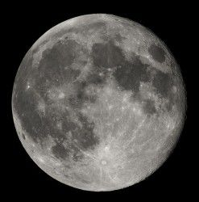
With more the 60 moons orbiting Jupiter, and 2 going around Mars, you might think that we should have plenty of moons orbiting Earth. But no, Earth only has one moon the Moon. Scientists think that the Moon was formed when a giant Mars-sized object crashed into the Earth, early on in its history. The enormous collision threw up a tremendous amount of debris. Most of it rained back down on the molten planet, but some of it stayed in orbit, and coalesced into the Moon we know today. Although there are many different names for the Moon: blue moon, harvest moon, new moon, full moon, it's all just describing the same object.
There are two other objects that some scientists have referred to as Earth's other moons, but they aren't really moons. The first is called 3753 Cruithne, and it's not a moon at all, but an asteroid that orbits the Sun. Since its orbit takes the same amount of time to orbit the Sun as the Earth, it sometimes looks like it's following Earth in orbit around the Sun. Although Cruithne's path comes very close to Earth, the two objects can never really collide because Cruithne's orbit is tilted to that of the Earth's by 19.8. It's a very interesting object, and has an orbit that interacts with Earth, Cruithne really doesn't quality as a satellite of Earth. The other object is called 2002 AA29, and it takes an even more bizarre orbit around the Sun. It spends most of its time in a horseshoe orbit, oscillating up and down near the Earth. Every 95 years or so, 2002 AA29 comes within 5.9 million km of Earth. Because it's so close to Earth, scientists have suggested that it might make an ideal target for a space mission to retrieve a sample and bring it back to Earth. Astronomers thought they might have discovered another moon in 2002, which they designated J002E3. But it turned out to be the third stage of the Apollo 12 Saturn V rocket.

Phases of the Moon:
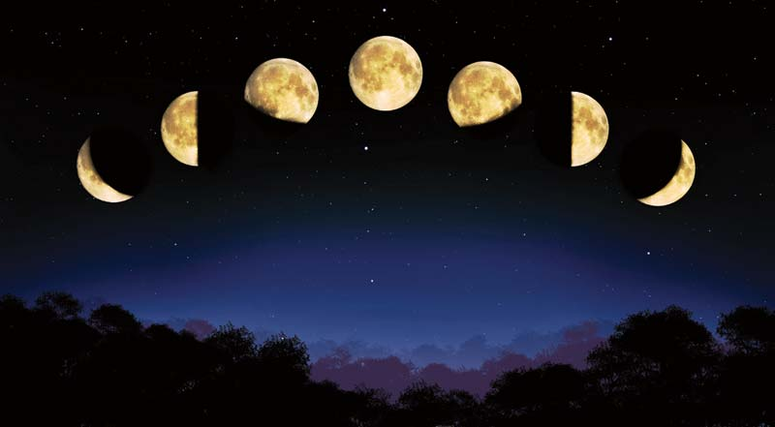
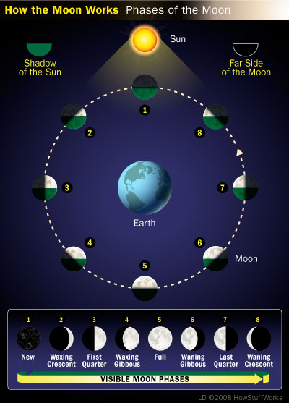
https://www.khanacademy.org/partner-content/nasa/measuringuniverse/spacemath1/v/lunareclipse - lunar eclipse explained

http://www.sciencekids.co.nz/gamesactivities/earthsunmoon.html. - for middle primary students on orbits of Earth, Sun and Moon, younger could play but older would get bored quickly.
http://www.schoolsobservatory.org.uk/astro/esm/shadows
Simple animation for shadows

Moons in the Solar System
Moons -- also called satellites -- come in many shapes, sizes and types. They are generally solid bodies, and few have atmospheres. Most of the planetary moons probably formed from the discs of gas and dust circulating around planets in the early solar system. Astronomers have found at least 146 moons orbiting planets in our solar system. Another 28 moons are awaiting official confirmation of their discovery. This number does not include the six moons of the dwarf planets, nor does this tally include the tiny satellites that orbit some asteroids and other celestial objects.
Of the terrestrial (rocky) planets of the inner solar system, neither Mercury nor Venus have any moons at all, Earth has one and Mars has its two small moons. In the outer solar system, the gas giants Jupiter and Saturn and the ice giants Uranus and Neptune have numerous moons. As these planets grew in the early solar system, they were able to capture objects with their large gravitational fields.
Earth's Moon probably formed when a large body about the size of Mars collided with Earth, ejecting a lot of material from our planet into orbit. Debris from the early Earth and the impacting body accumulated to form the Moon approximately 4.5 billion years ago (the age of the oldest collected lunar rocks). Twelve American astronauts landed on the Moon during NASA's Apollo program from 1969 to 1972, studying the Moon and bringing back rock samples.
Usually the term moon brings to mind a spherical object, like Earth's Moon. The two moons of Mars, Phobos and Deimos, are different. While both have nearly circular orbits and travel close to the plane of the planet's equator, they are lumpy and dark. Phobos is slowly drawing closer to Mars and could crash into the planet in 40 or 50 million years. Or the planet's gravity might break Phobos apart, creating a thin ring around Mars.
Jupiter has 50 known moons (plus 18 awaiting official confirmation), including the largest moon in the solar system, Ganymede. Many of Jupiter's outer moons have highly elliptical orbits and orbit backwards (opposite to the spin of the planet). Saturn, Uranus and Neptune also have some irregular moons, which orbit far from their respective planets.

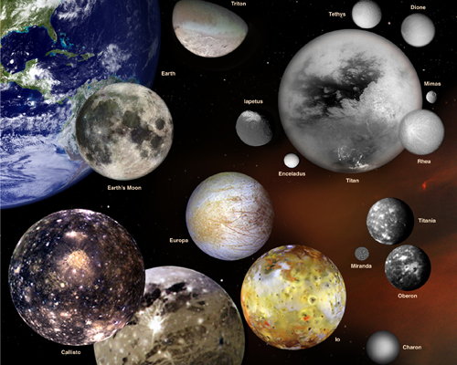

Pan is responsible for a gap in Saturn's rings.

Saturn has 53 known moons (plus 9 awaiting official confirmation). The chunks of ice and rock in Saturn's rings (and the particles in the rings of the other outer planets) are not considered moons, yet embedded in Saturn's rings are distinct moons or moonlets. These shepherd moons help keep the rings in line. Saturn's moon Titan, the second largest in the solar system, is the only moon with a thick atmosphere.
In the realm of the ice giants, Uranus has 27 known moons. The inner moons appear to be about half water ice and half rock. Miranda is the most unusual; its chopped-up appearance shows the scars of impacts of large rocky bodies.
Neptune has 13 known moons. And Neptune's moon Triton is as big as the dwarf planet Pluto and orbits backwards compared with Neptune's direction of rotation.
Pluto's large moon Charon is about half the size of Pluto. Like Earth's Moon, Charon may have formed from debris resulting from an early collision of an impactor with Pluto. In 2005, scientists using the Hubble Space Telescope to study Pluto found two additional, but very small, moons. The little moons Nix and Hydra are about two to three times as far from Pluto as Charon and roughly 5,000 times fainter than Pluto. Eris, another dwarf planet even more distant than Pluto, has a small moon of its own, named Dysnomia. Haumea, another dwarf planet, has two satellites, Hi'iaka and Namaka.

How the Moons of Our Solar System Get Their Names
Most moons in our solar system are named for mythological characters from a wide variety of cultures. Uranus is the exception. Uranus' moons are named for characters in William Shakespeare's plays and from Alexander Pope's poem "Rape of the Lock." Moons are given provisional designations such as S/2009 S1, the first satellite discovered at Saturn in 2009. The International Astronomical Union approves an official name when the discovery is confirmed.

What is the difference between Asteroids and Meteors?
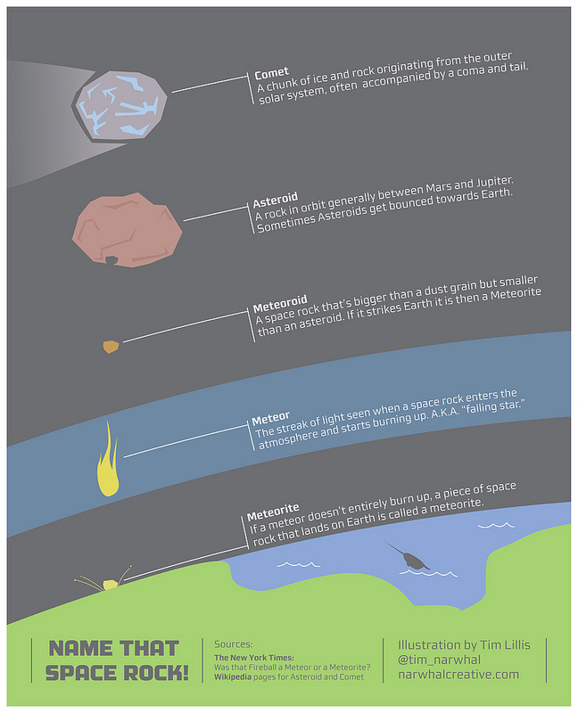

Building Science Concepts book: The Moon Book 8

Building Science Concept book Our Star, the Sun Book 20

A website about the sun – reading material that students could use to gather facts http://academic.brooklyn.cuny.edu/physics/sobel/Nucphys/sun.html

http://www.kidsastronomy.com/solar_system.htm - very student friendly, probably better resource
With this youtube clip http://www.youtube.com/watch?v=OYVmekXH17M - for young children. I think it would be a really good idea for young children to learn a little bit about the sun as in it, it says “sun please shine on me” in an activity you would be able to expand on that and see if the children know what would happen if there was no sun in the world.

The Night Sky Building Science Concept book 28

Extra Videos of Interest
Size comparisons of our Solar System and then some much bigger stars:
http://www.youtube.com/watch?v=CubFmoRvwWQ this one gives size of planets plus a visual of size difference

How to make a comet:
https://www.youtube.com/watch?v=FY_SFxP_jH0
Need a large bowl/metal cooking pot lined with plastic (bin liner works best), wear gloves for this and eye protection
Add:
- 1/2 litre water
- 1 cup of dirt
- 1/2 tablespoon starch
- 1/2 tablespoon syrup
- 1/2 tablespoon vinegar
- 1/2 tablespoon rubbing alcohol
Mix well
Add 1 kilo of dry ice and then pull up sides of plastic/bin liner to help form up the comet into ‘rock’ and wearing gloves you have a comet in your hands.

Otago Central rail trail to become 100 million to one model replica of the Solar System
KATARINA WILLIAMS
November 13 2016 (stuff.co.nz)
Retrieved from http://www.stuff.co.nz/travel/news/86256117/otago-central-rail-trail-to-become-100-million-to-one-model-replica-of-the-solar-system
The quiet settlement of Ranfurly, about 100 kilometres north of Dunedin, could soon be laying claim to being at the centre of the universe.
A pilot programme - due to get underway in late summer - will see the Otago Central Rail Trail become a 100 million to one scale model of the Solar System.
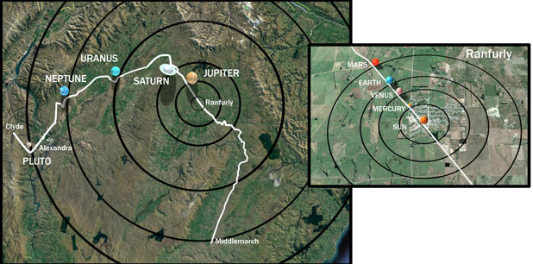
The unique concept will allow families and school groups to learn about science while cycling along the popular 152km trail which stretches from Middlemarch to Clyde.
Models and interpretive signage will help transform the trail into an "outdoor classroom" which will see Ranfurly play home to the Sun.
Its sheer size means the model will need to be 14m in diameter, with the possibility a sun dial will be used to represent it.
Central Otago mayor Tim Cadogan, pictured with his wife Linda, has thrown his weight behind the pilot programme, calling it a "great initiative".
"Ranfurly is a great, little town. It's not quite the centre of the rail trail, but it's near enough to it and I think the people of Ranfurly would welcome anything that keeps them on the map," Cadogan said.
"If we look at books, all the planets are squashed onto one page and it's nothing like that. I think it's a great initiative."
The model of Earth will sit around 1.5km from central Ranfurly and will be just 14cm in diameter.
Saturn will end up 'orbiting' very close to the iconic Wedderburn Tavern which was built back in 1885 at what is the cycling trail's halfway point.
The models will be designed to compliment their rural location, with recycled barb wire spheres possibly being used to represent hostile gas giants.
If the pilot programme - beginning in February or March next year - was considered a success, the models could become permanent features.
The project has received $24,000 from the Ministry of Business, Innovation and Employment's Unlocking Curious Minds fund.
Interplanetary Cycle Trail
Scale: 100 million to one model of the Solar System
Distance from the Sun (km) + Diameter (m)
Sun - Ranfurly - 13.91m
Mercury - 0.579 km - 0.049m
Venus - 1.082 km - 0.121m
Earth - 1.496 km (Moon 3.844m) - 0.128m (Moon 0.035m)
Mars - 2.279 km - 0.068m
Jupiter - 7.783 km - 1.429m
Saturn - 14.246 km - 1.205m
Uranus - 28.736 km - 0.511m
Neptune - 45.01 km - 0.495m
Pluto - 59.06 km - 0.024m

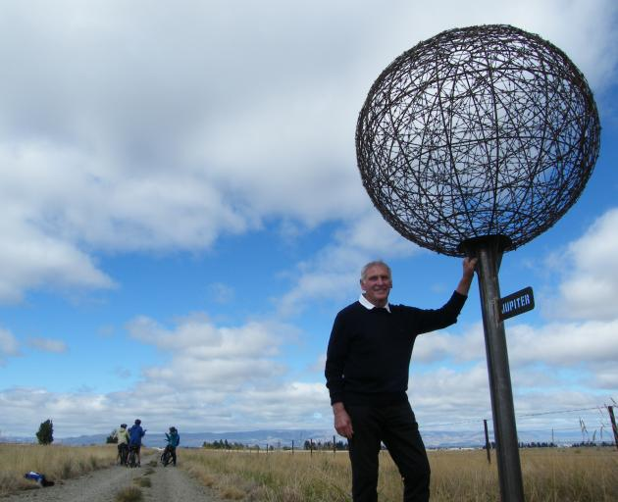
Solar system to scale on Rail Trail
By Pam Jones 16 March 2017 (Otago Daily Times)
Retrieved from https://www.odt.co.nz/regions/central-otago/solar-system-scale-rail-trail

Otago Central Rail Trail operator Graeme Duncan, of Wedderburn, casts his eye over a miniature Jupiter while flanked by cyclists on the rail trail between Ranfurly and Wedderburn. The planet is one of nine in a scale model solar system on the rail trail, with earth's moon and the sun also part of the project.
Earth is just 12cm, the sun almost 14m and Jupiter a barbed wire ball somewhere in the middle.
Such is the scale of the solar system when recreated on the Otago Central Rail Trail in an ''interplanetary cycleway'' that is having its first visitors.
The project has seen a 1:100,000,000 scale model of the solar system installed between Alexandra and Ranfurly. Earth's moon and the sun have also been recreated, and orbits of the planets will later be installed between Ranfurly and Middlemarch.
The joint rail trail and Otago Museum project - conceived by Cromwell man Ian Begg - received $24,000 from the Ministry of Business, Innovation and Employment's ''Unlocking Curious Minds'' scheme.
The resulting solar system allowed people to ''contemplate the immensity of space'' as they travelled the rail trail, with some staggering scientific statistics, rail trail chairwoman Kate Wilson said.
Each step people take on the rail trail was the same as travelling 75,000km through the solar system, and each revolution of their bike wheel would propel them more than 200,000km.
Rail trail operators and local schools embraced the project, and workshops held with local school children helped them comprehend space and time, Ms Wilson said.
As well as presenting a range of scientific concepts in an engaging way, the project would also focus visitors on the ''amazing night-time landscape the area offered'', she said.
At this stage the planets - installed last week - were being treated as a pilot, but if the project was well received planets would also be installed on the eastern orbits of the trail, from Ranfurly to Middlemarch, Ms Wilson said.
A more permanent sun model is being brainstormed to replace the temporary rope and warratah structure riders cycle through in Ranfurly.

NASA’s website for STEM in space – better for extension activities
https://www.nasa.gov/audience/foreducators/stem-on-station/science
Better are the youtube videos about space:
https://www.youtube.com/watch?v=TU9kffoAQ8U – how you brush your teeth
https://www.youtube.com/watch?v=MgMYqxdVAlA – how you go to the bathroom
https://www.youtube.com/watch?v=1v5gtOkyCG0 – why you cannot cry in space
https://www.youtube.com/watch?v=Rp1Mgbu4H3o – what does space smell like 2:36-3:04
http://askascientist.co.uk/space/what-happens-when-you-wring-out-a-wash-cloth-in-space/

