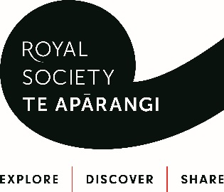

ASK ME A QUESTION FORM
(for up to Year 8 Students)
School:
Student’s name:
Year Level:
Age:
What is the topic you want to ask your question about?

What is your question?

Send this form to: askmeaquestion@royalsociety.org.nz
Material World  For example, your question could be about chemical reactions, chemical matter and properties... 'What’s in sunscreen that protects you from the sun's rays?’ or ‘Why does jelly wobble?’  Questions to be received by 24 March | April
Physical World  For example, your question could be about forces, motion, gravity, magnetism, light, sound, waves, electricity...  Questions to be received by 24 April | May
Space/Astronomy  For example, your question could be about planets, stars, space travel...  Questions to be received by 24 May | June
Living World  For example, your question could be about plants, animals, the world around you, groupings of plants and animals, extinction...  Questions to be received by 23 June | July
Technology  For example, your question could be about product development, computers, robotics...  Questions to be received by 24 July | August
Planet Earth & Beyond  For example, your question could be about landforms, rocks, earthquakes, volcanic eruptions, soil, landslides...  Questions to be received by 24 August | September
Social Science/Globalisation  For example, your question could be about the movement of people and how it affects cultural diversity and interaction within New Zealand, navigation, rules and laws, how people make decisions, how people influence places and how places influence people, cultural practices...  Questions to be received by 25 September | October

