Before we get started, to whet you appetites think about this ...
With a budget of, say, $60 billion,
which of these geo-engineering projects would you select?

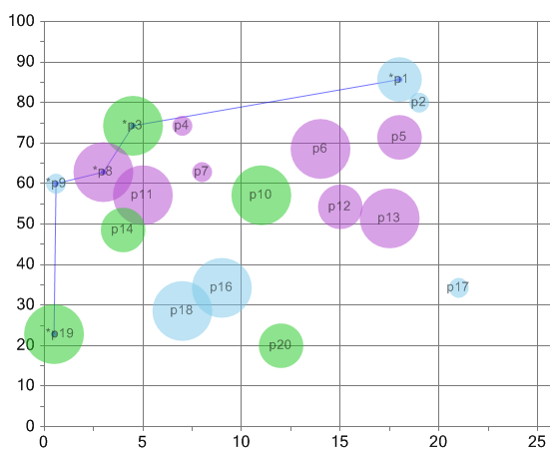
(index)
NET COST (NPV, $ billion)

CONFIDENCE in
Net Cost Estimates
ie. larger bubbles
= greater certainty

GEO-POLITICAL RISK
ie. green = low
light blue = medium
purple = high

Plan for today

- Multi-Criteria Decision-Making → (quick) theoretical background
- Decision-support software → a worldwide industry
- 1000Minds – workshop



www.1000minds.com
Multi-Criteria Decision-Making (MCDM)
→ Prioritising, or ranking, or choosing from amongst competing alternatives, based on considering multiple criteria (or objectives) …

(very similar to ‘Conjoint Analysis’ and ‘Discrete Choice Experiments’)

1000s of MCDM applications …

eg.
Investment Appraisals
– Ranking investment or project proposals
- CAPEX

Procurement Decision-Making
– Evaluating supplier proposals
– Assessing value for money
- Allocating budgets

Homeland Security, Military & Defence
– Prioritising security / terrorism threats
– Assessing intelligence
– Prioritising ‘special projects’

Strategic Planning
– Prioritising organisation’s objectives

Health Care
– Prioritising patients for treatment
– Managing waiting lists
– Health Technology Assessments
– Advanced planning for pandemics

Environmental Management
– Environmental impact assessments
– Planning notifications

Local Body Decision-Making
– Prioritising investment projects
– Ranking community-funding grant applications

1000s of MCDM applications … (2)

Immigration
–Points Systems for selecting immigrants

Utilities Management
– Ranking project proposals
– Environmental planning

Research Funding
– Ranking grant applications

Education
– Awarding scholarships
– Admitting students to med, pharmacy & law schools

Marketing Research & New Product Design
– Choice-based Conjoint Analysis

Police & Emergency Services
– Prioritising police & emergency services responses

Human Resource Management
– Short-listing job applicants
– Appraising CEO candidates
– Staff appraisals for bonuses & promotions

Finance, Banking & Insurance
– Short-listing assets for portfolios
– Capital budgeting
– Credit scoring
– Detecting fraud

Business Opportunities
– Ranking start-ups, company acquisitions & investment opportunities
– Allocating ‘angel’ & venture capital
– Portfolio management

Competitions & Awards
– Judging

... etc., etc. etc.

Multi-Criteria Decision-Making (MCDM)
eg. ‘Points / Scoring System’
3 Key Elements of ALL MCDM Decisions
Efficacy: Degree of testing
Low 0
Medium 12
High 25
Safety: Verification
Low 0
Medium 11
High 18
Safety: Negative side-effects
Low 0
Medium 9
High 14
Rapidity: Emergency stop
Low 0
Medium 12
High 19
Rapidity: Mitigation rate
Low 0
Medium 19
High 24
ETC, ETC (other criteria & considerations)

Plus Net cost (NPV - include later)
(‘ART’ & ‘SCIENCE’)
1. ALTERNATIVES to be prioritised
eg. geo-engineering projects

2. CRITERIA (or OBJECTIVES) by which alternatives are to be prioritised / ranked
... can be quantitative or qualitative, as appropriate ...

3. RELATIVE IMPORTANCE of the criteria
ie. ‘weights’ or ‘points’

→ Describe ALTERNATIVES on the CRITERIA
via the Points Systems …
→ Ranking of Projects

→ Make decisions subject to a budget constraint
In general, Points Systems have been found to be very accurate ...

According to Hastie & Dawes (2001, p. 53 & 62):
[Points systems are] surprisingly successful in many applications. We say surprisingly because many judges claim that their mental processes are much more complex than the linear summary equations would suggest but empirically the equation does a remarkably good job of ‘capturing’ their judgment habits.

… [This is because the human] mind is in many essential respects a linear weighting and adding device. In fact much of what we know about the neural networks in the physical brain suggests that a natural computation for such a ‘machine’ is weighting and adding, exactly the fundamental processes that are well described by linear equations.

Similarly, according to Hadorn et al. (2003, p. 49):
[Points systems] are, as a rule, more accurate than human predictors. This is not surprising, as it has been known for decades that human cognitive performance is limited with respect to complex multi-variable judgment and prediction tasks.
Common mistakes people commit when making important decisions
Decision by Objectives, E Forman & M Selly (2001), p. 4; http://mdm.gwu.edu/forman/DBO.pdf

FAQ #1
How does Multi-Criteria Decision-Making (MCDM) relate to Cost-Benefit Analysis (CBA)?

Answer: They’re complementary ...

Use MCDM to combine ‘Benefit’ defined on multiple dimensions – including financials – into a single measure (‘Benefit index’)

And leave ‘Cost’ in NPV terms
→ Benefit-Cost Ratios, etc
MCDM Software (worldwide industry)

International Software Survey:
http://lionhrtpub.com/orms/surveys/das/das.html

Expert Choice Decision Lens
www.expertchoice.com www.decisionlens.com
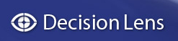
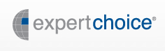

etc ...

1000Minds
www.1000minds.com


1 Article & 4 Patents (so far) | Innovation Awards
P Hansen & F Ombler, “A new method for scoring multi-attribute value models using pairwise rankings of alternatives”, Journal of Multi-Criteria Decision Analysis 15, 87-107 (2009)  Hansen & Ombler, Patent No. 7552104, United States Patent & Trademark Office (2009)  Hansen & Ombler, Patent No. 200423, IP Office, Australian Government (2007)  Hansen & Ombler, PCT No. PCT / NZ04 / 00121, International Preliminary Examining Authority (2005)  Hansen & Ombler, Patent No. 526447, Intellectual Property Office of New Zealand (2004)  Hansen & Ombler, Patent No. 527785 (cognated), IP Office of NZ (2004)  + Canadian patent pending | Winner, Consensus Software Awards 2007 (“The only independently judged Awards for Australian & NZ software, sponsored by Microsoft and IBM”)  Winner, Telecommunications Users’ Association of NZ (TUANZ) Healthcare Innovation Award 2005  Finalist, TUANZ Education Innovation Award 2009  Finalist, Bayer Innovators Award 2008  Finalist, Global Entrepolis @ Singapore Award 2005  Finalist, 2006 NZ Health Innovation Awards  Finalist, Westpac Otago Chamber of Commerce Business Excellence Innovation Awards 2006
How are the weights (‘point values’) determined?
Efficacy: Degree of testing
Low ??
Medium ??
High ??
Safety: Verification
Low ??
Medium ??
High ??
Safety: Negative side-effects
Low ??
Medium ??
High ??
Rapidity: Emergency stop
Low ??
Medium ??
High ??
Rapidity: Mitigation rate
Low ??
Medium ??
High ??
ETC, ETC (other criteria & considerations)

Plus Net cost (NPV - include later)
‘Scoring’ methods
1. Arbitrarily-chosen points/weights (‘direct rating’)
eg. Off the top of your head, how many points is ‘Extreme’ Efficacy: Degree of testing ... worth? etc.

2. Regression or ‘conjoint’ statistical analysis

3. Formal methods from Operations Research,
based on decision-makers’ expert knowledge
& preferences (implemented via software):
- SWING
- SMART (Simple MultiAttribute Rating Technique)
- SMARTER
- AHP (Analytic Hierarchy Process), used by Expert Choice and Decision Lens software
- PAPRIKA (Potentially All Pairwise RanKings of all possible Alternatives), used by 1000Minds
eg. Analytic Hierarchy Process (AHP)
… used by Expert Choice & Decision Lens software ...

→ elicit ratio scale measurements of users’ preferences:
eg. How many times more important is Efficacy: Degree of testing …
than
Safety: Verification ?

Ratio
(Intensity of preference)
Equal importance | = 1 × more important
Moderate importance | = 3 × more important
Strong importance | = 5 × more important
Very strong importance | = 7 × more important
Extreme importance | = 9 × more important

R Haas & O Meixner, An Illustrated Guide to the Analytic Hierarchy Process.
Available from http://www.boku.ac.at/mi/ahp/ahptutorial.pdf
PAPRIKA method
(Potentially All Pairwise RanKings of all possible Alternatives)
… used by 1000Minds software ...
P Hansen & F Ombler, “A new method for scoring multi-attribute value models using pairwise rankings of alternatives”, Journal of Multi-Criteria Decision Analysis 15, 87-107 (2009)
And see: http://en.wikipedia.org/wiki/Potentially_all_pairwise_rankings_of_all_possible_alternatives
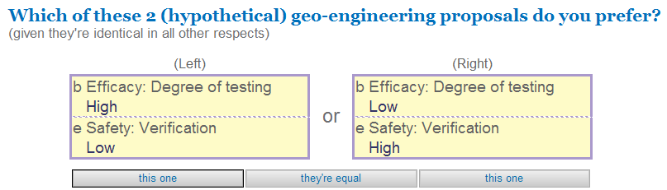

Ordinal measurements → simplest & least cognitively difficult of all methods for users …
→ greater validity & reliability. (But requires stamina!)
“The advantage of choice-based methods is that choosing, unlike scaling, is a natural human task at which we all have considerable experience, and furthermore it is observable and verifiable.” (Drummond et al. Methods for the Economic Evaluation of Health Care Programmes, 2005)

Thank You

1000Minds: www.1000minds.com

Rational Choice in an Uncertain World. The Psychology of Judgement & Decision Making. Sage Publications, California.
“Setting priorities on waiting lists: Point-count systems as linear models”, Journal of Health Services Research & Policy 8.

